Multi-Objective Evolutionary Algorithms Lecture Notes

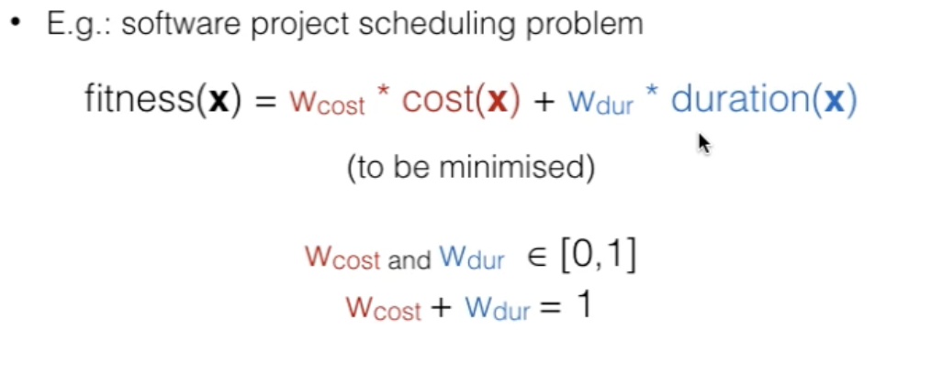
To deal with multi-objective problems by using single-objective optimisation algorithms, the multiple objectives have to be combined into a single fitness function

This fitness function is the weighted average of both cost and duration
For the app, the fitness function would be x = w_{time} * time(x) + w_{satisfaction} * satisfaction(x)
Time to be minimised, satisfaction to be maximised.

The advantage of combining objectives into one single objective function -> once the weights are set, any single objective optimisation algorithm can be used ie is very applicable

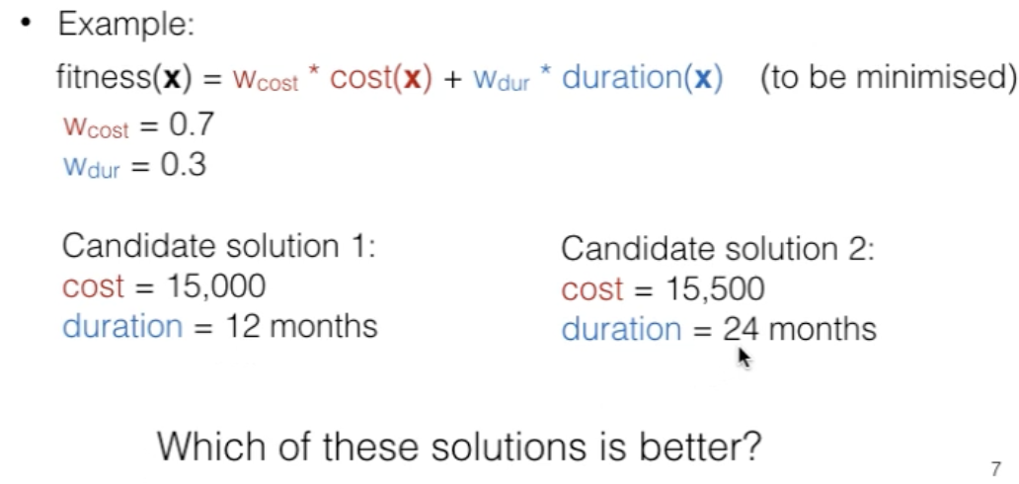
Disadvantage 1 -> Finding suitable weights is not easy before knowing what different trade-offs between objectives may be available

Candidate solution 1 is better – lower cost and lower duration

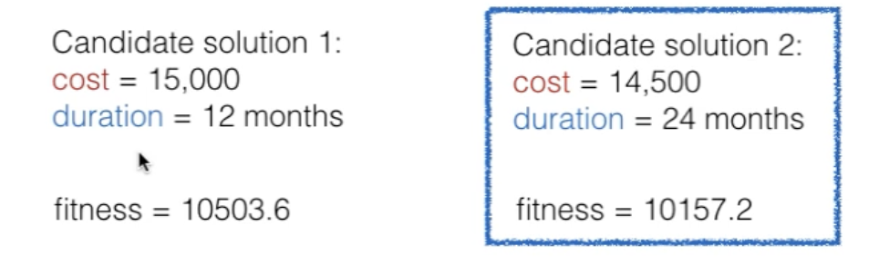
2 is better here as cost is lower and the weight setting for cost is higher than of duration therefore it has a higher priority

Disadvantage 2-> if different objectives have different scales, weights have to reflect preferences towards certain objectives, but also treat and acknowledge the different scales eg in the above example, cost may vary from 1000 and 100,000, whereas duration may vary between 3 and 40.

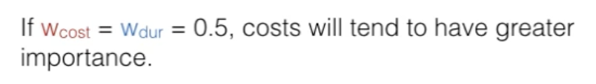

Disadvantage 3 –> weights will strongly affect the results

Solution to this – using multi-objective evolutionary algorithms
- Advantages
  - Scale does not matter
  - No need to set weights
  - These algorithms retrieve a set of solutions with different trade offs

What is GUI Main? The software used to create the algorithms

- Disadvantages
  - It is difficult to visualise trade-offs among >3 objectives
  - Some multi-objective evolutionary algorithms also struggle to produce good solutions when we have >3 objectives
  - (these disadvantages are not applicable in my app, only uses 2 objectives – distance and satisfaction (closeness to the selected category)).

Non-dominated Sorting Genetic Algorithm II (NSGA-II)
- Based on selective pressure that EAs put on solutions to choose better solutions/children for next generation
- Concept – instead of comparing a single fitness value across 2 or more solutions (like above), NSGA-II is based on the concept of dominance across multiple objectives to find the best solution

Dominance
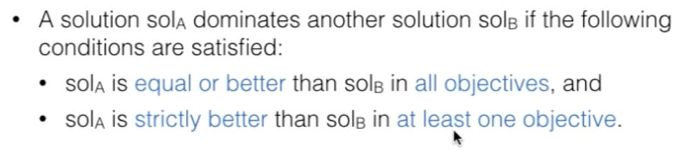

E.g.
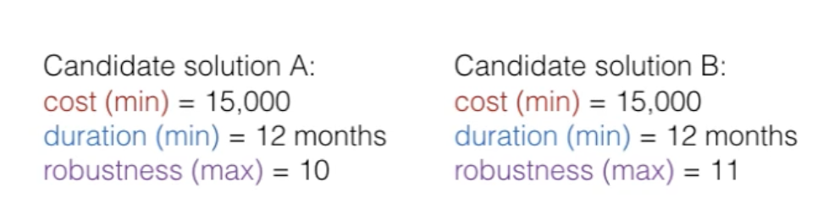

- A does NOT dominate B as robustness of 10 < robustness of 11
- But B does dominate A for the same reason – cost and duration are the same, but robustness of B>A.

Instead of having single best solutions, we have SETS of best solutions with different trade-offs
This set of solutions is called the Pareto Front: set of solutions that are non-dominated by any other solution in the search space (ie the best one)

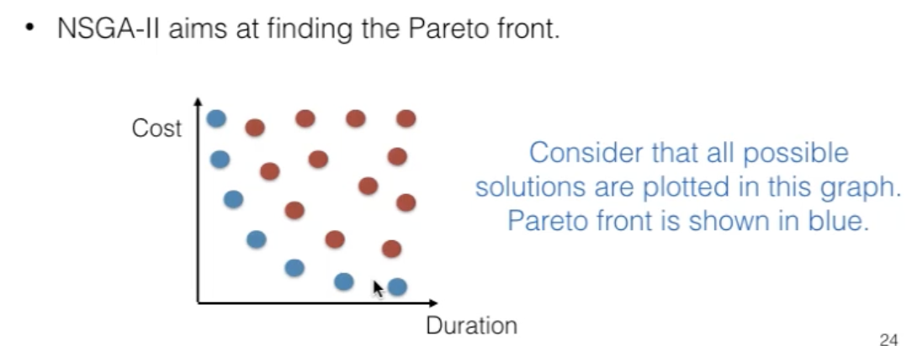

Non-dominated fronts
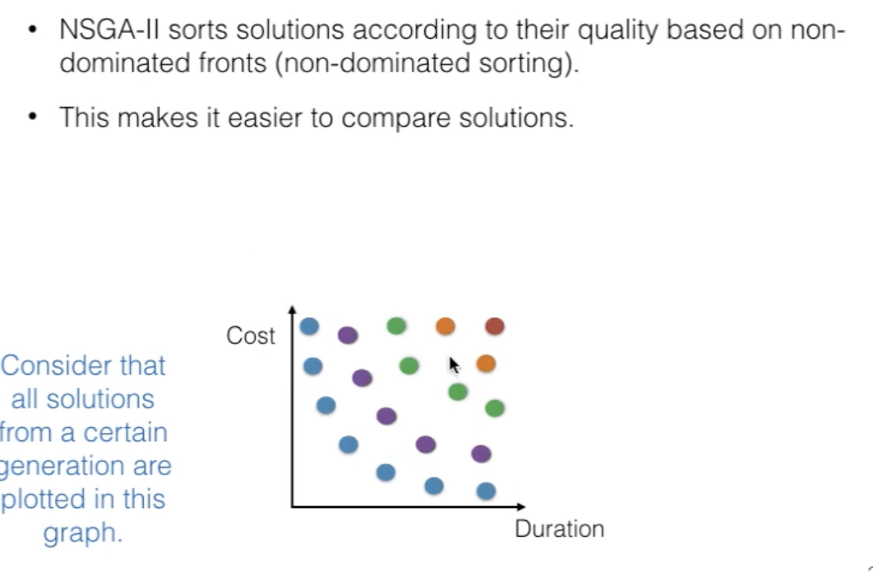
Remove each layer one by one then observe which are non-dominated by others and put aside
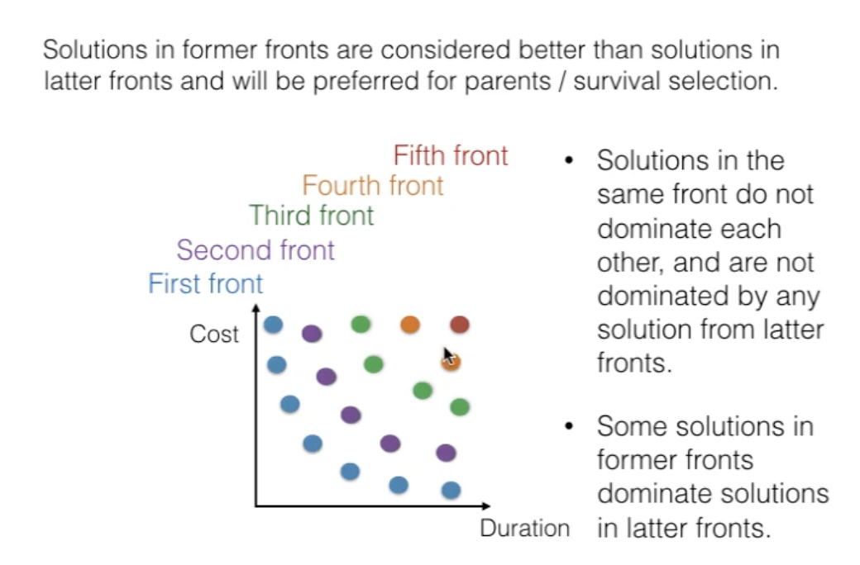

Then the NSGA-II considers solutions in former fronts as better than solutions in latter fronts, and prefers them during parent selection
BUT many solutions are non-dominated by eachother – how do we pick best solutions in the same front?
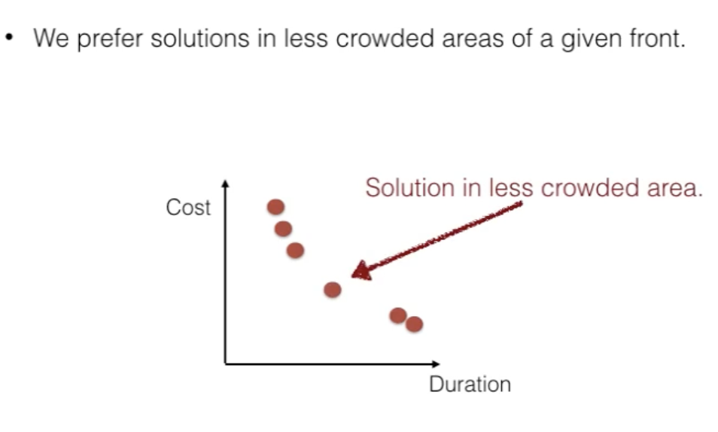
How do we determine crowding?
- Crowding distance
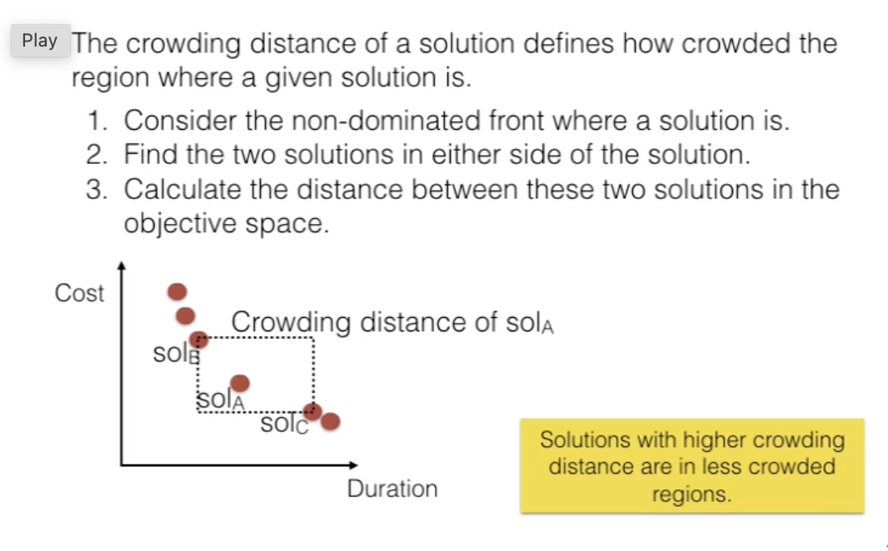

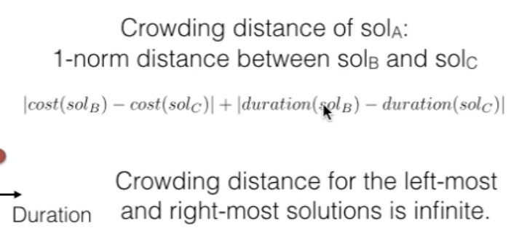

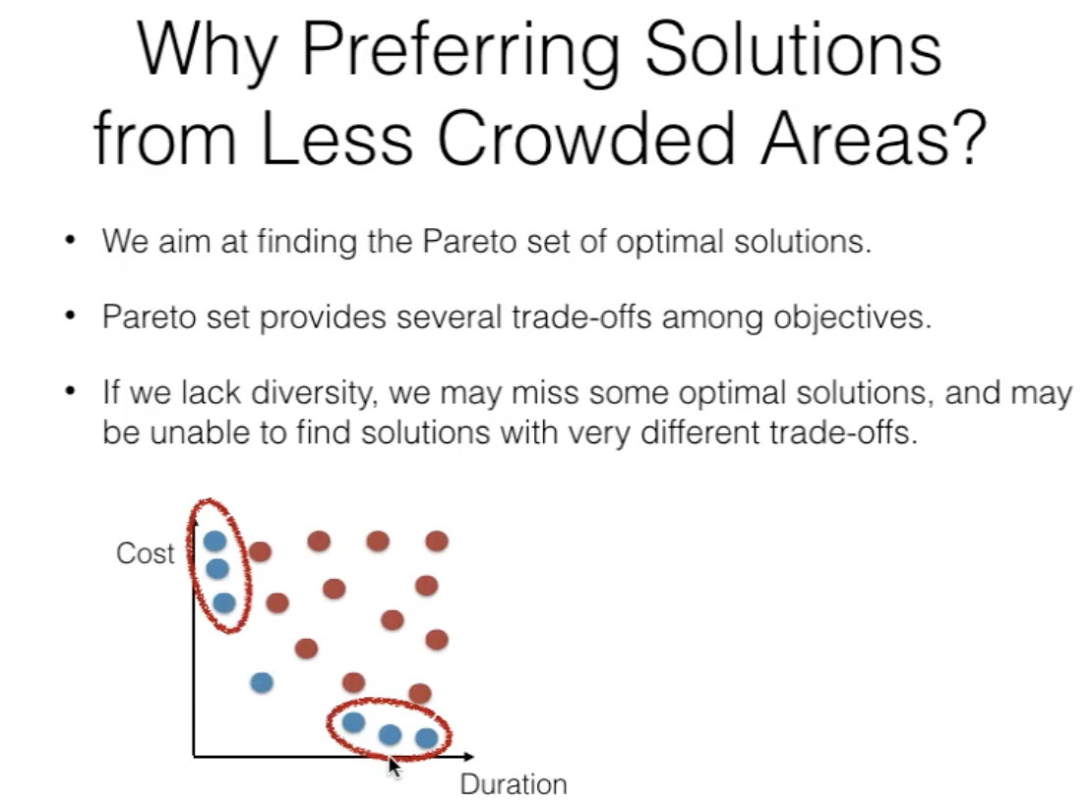
To ensure good coverage of trade offs – ie so all range can be hypothetically covered – helps to find the Pareto set of trade-offs

Deciding between solutions (summary)
- If solution A is in a former non-dominated front than solution B, pick A
- If solution A and solution B are in the same non-dominated front, pick the solution from the less crowded area (ie with a HIGHER crowding distance).

NSGA-II ALGORITHM

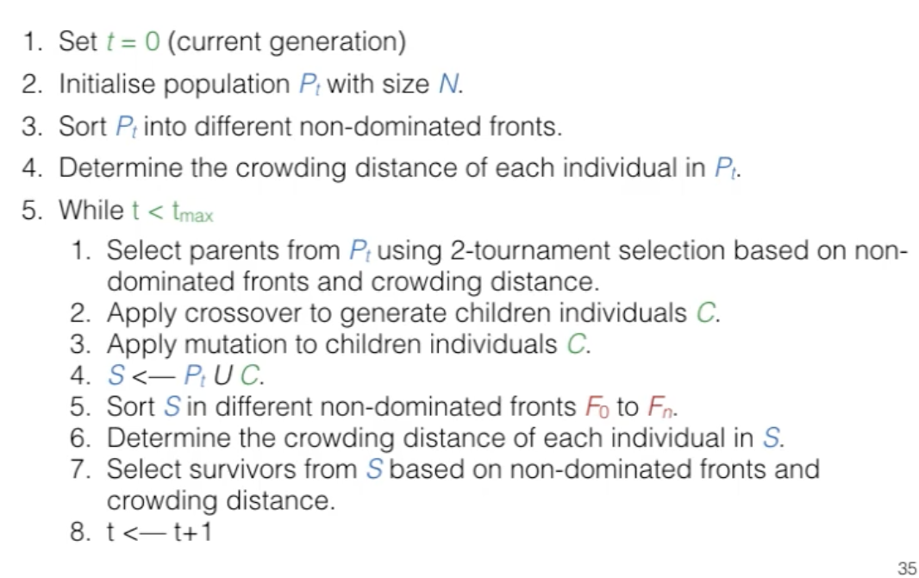

To pick survivors – elitism survivor selection
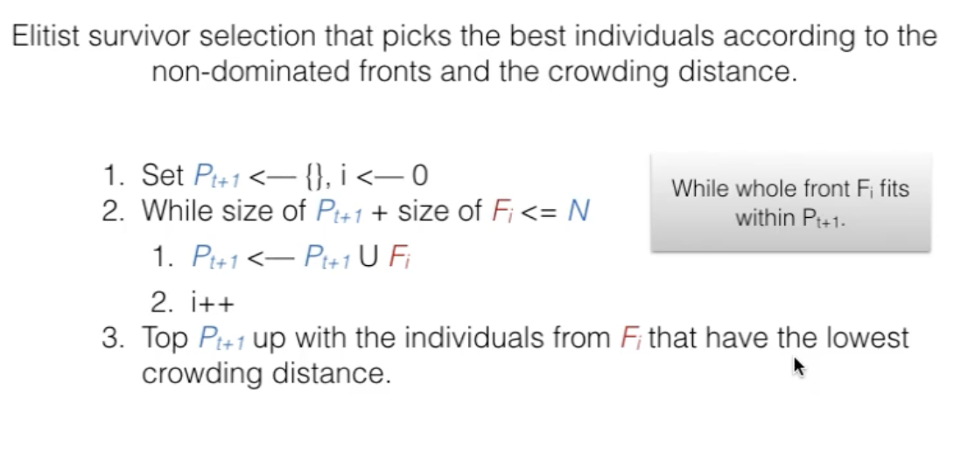
highest

F_{i} = new non dominated front
P_{t+1} = new population size

